1

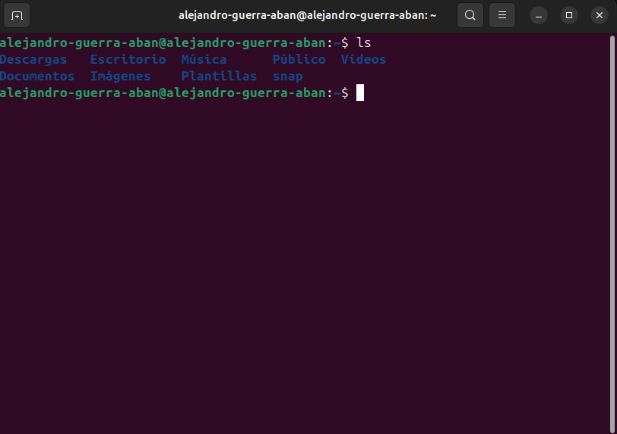
2 - 4


5 – 9

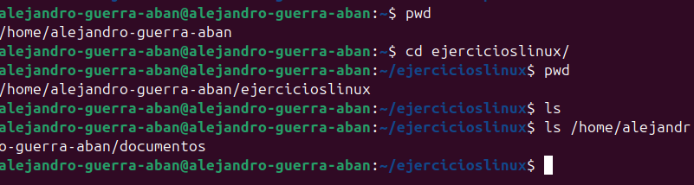

10 – 12



